**CURRICULUM VITAE**

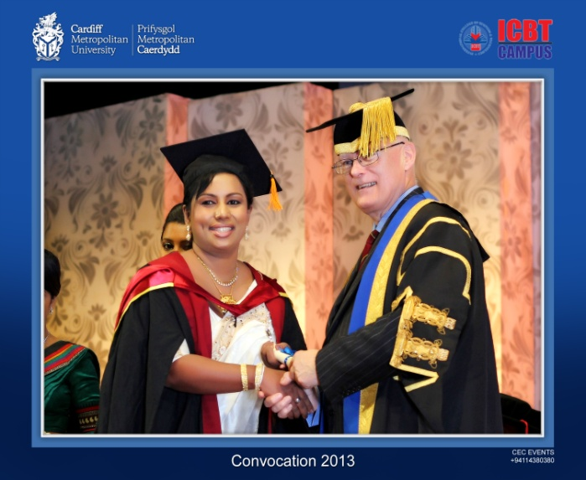

**Manuki Devanya Kalansuriyage,**

**No.3,Thalapathpitiya,Amarathunga Mawatha,Nugegoda**

**Mobile : +94 077-9716293/072-4791400**

**E-mail : minsaradi@gmail.com**

**PROFESSIONAL EXPERIENCE**

**W**

* ***Work at Kandy Royal International as the Chief Executive Principal for Kandy Royal Net Work from 2012 to date***
* ***Joined Kandy Royal International as the Principal from-2009 December***
* ***Vice Principal RI Gampaha***
* ***.***
* ***Teacher Trainer Royal International Pre-School and Primary Diploma in Teaching***
* ***Visited Maldives- SH -Komandoo Pre-School in for about three weeks completed as at 23rd of April 2012 –As a Voluntaries Teacher advisor and trainer***

**Personal Details:**

* **Name in Full : Manuki Devanya Kalansuriyage**
* **Date of Birth : 22.02.1978**
* **Gender : Female**
* **Nationality : Sri Lankan**
* **NIC No. : 785533470V/Passport No.N1468322**
* **School Attended : Mahamaya Girls’ College – Kandy**
* **Religion : Buddhist**
* **Age : 35years**

**PROFESSIONAL QUALIFICATIONS**

* + **MBA (UWIC) Masters in business Administration( Registered No: UWIC-20023827**
* **AVCM graduate- Associate ship in speech and Drama (TD Hons) London – Victoria College London.**
* **Gained the right to use the letters A.V.C.M.(T.D) (Hons) London-Registered no:667717**
* **Completed the Diploma in Pre-School and Primary school Education and Practical Training.(The Open University SriLanka-Dip.OUSL) Registered no;50698513**
* **Diploma in Montessori, Pre-School and Primary method of Education and Practical Training.(Asian International-Dip.AISL) Reg no;170847**
* **Teachers Certificate in Teaching of English to Intermediate Learners.**

**(CALSDA-SriLanka)**

* **Teachers Certificate in Teaching of English to Young Learners.**
* **(CALSDA-SriLanka.)**
* **Part qualified in Diploma in Speech and drama-CALSDA Sri Lanka.**
* **Certificate in Communication Skills for Executives Course Conducted By the University of Moratuwa. Regesterd No:ELTC/CSFE/08/041**
* **Diploma in Computer Systems Analysis And Design course conducted by The Informatics Information Systems, Pvt Limited.**

**Registered Speech and drama teacher in London**

**Teachers’ Registration code: 8528**

**University of West London –London College of Music Examinations, St.Mary’s Road, Ealing, London, W5 5RF –TP: 02082312364**

**Local body Registration as an English and Speech and Drama Teacher**

**Mystical Rose International Institute of Performing Arts- Registration Sri Lanka No; 137**

**International Institute of Music and Speech and Drama Registration Number; 799-Corporate Member of Society of Teachers of Speech and Drama UK**

* **Preparing students for local and foreign exams-speech and drama, miming, acting, spoken English, Oral communication, verse speaking examinations, Witten English Graded Examination Trinity Guild Hall-London**

**WORKING w**

* **Served in a number of schools-language skills, teaching methods/material, classroom management, schemes of work, communicative activities, audio visual aids and visual aids, effective teaching strategies and assessment of students’ progress.**
* **Preparing a number of students for local and foreign spoken and Speech and Drama examinations. Including LCM and New Era UK Examinations which will provide word recognized NVQ Qualifications for teachers and students.**
* **Involved in Performing Arts Teaching at Mystical Rose International School.**
* **With more than 15 years of experience being involved in the Education Sector of Sri Lanka. And also in organizing concerts, Annual Competitions for the whole net work of Schools including seven branches around central Province, Organizing western band shows, Cultural Festivals, and many other different social activities Sending students for IWMS Examinations,Sri-Lanka which is registered under the parliament act of Sri-Lanka**

Dear Madam/Sir,

Good day. I am interested to work in your organization for a suitable Post.

My name is Manuki Kalansuriyage. I have sent you my resume that is enclosed with this application.As seen on my resume, I hold a masters degree in Business Administration and a professional license in teaching. I have been working as the Chief Executive Principal at Royal International, Kandy 2009-2013.Iam also capable in teaching Business Studies for National, Cambridge and Edexcel Syllabus. More over I am capable in teaching Effective Speech and Speech and Drama. I am also highly confident in training students for British Festivals in Performing Arts.

My key job functions and responsibilities include:

-Managing all school personnel

-Plan and carry out programs, curriculum activities, policies, and budgets that enhance the educational development outlook of each student and encourage the professional growth of all teachers

-Classify the annual objectives for the instructional, athletic, and extracurricular programs of the school

-Assess growth of the students and managing and inform the performance of the teachers

My resume emphasizes specific examples of my administrative and leadership duties. I have been complemented on numerous occasions by the school superintendent on my strong problem-solving, creative thinking, and long-range planning abilities. In addition, I am skilled in communicating with a varied population.

Career Objective:

To efficiently work in any given Position in the Management, I will have to provide instructional leadership to faculty and its staff, carry out hands-on academic and behavioral interventions to improve student accomplishment, and directing well-organized management of the school facility.

To attain an administrative position that will make use of my abilities in communications, public relations, collaboration, technology, curriculum, instruction and supportive leadership which will result in a positive learning environment making sure that the involvement and success of all stakeholders.



Vision Statement

To continually improve the quality of education by providing instructional leadership for research based reading programs, fostering a safe environment conducive to learning, and championing parental involvement.

* Character Building stresses the importance of morals and significantly reduces disciplinary problems, providing a thriving learning environment at school.
* Reading Encouragement instills a love of learning which will be used throughout a lifetime to obtain knowledge at all levels.
* Direct Parental Involvement produces extremely successful learning results and builds a positive home/school connection.

Profile of Qualifications

Dedicated and highly motivated Educational Administrative Professional with a proven track record for implementing successful programs that produce lasting results. Active in supporting and encouraging teachers through continuing education, staff development, and leadership roles. Knowledgeable of current trends in education and capable of motivating staff to try new, creative techniques to continually improve teaching skills. Polished public speaker and instructor. Able to relate effectively to people at all levels and of diverse backgrounds. I hope you will give me the opportunity of a personal interview to help me understand your needs better and explain to you in greater detail how I can contribute to your school system. Thank You

**I certify that the above mentioned particulars of mine are true. Expected for a favorable reply.**

**Yours Faithfully,**

**Manuki Kalansuriyage**

**05/05/2014**